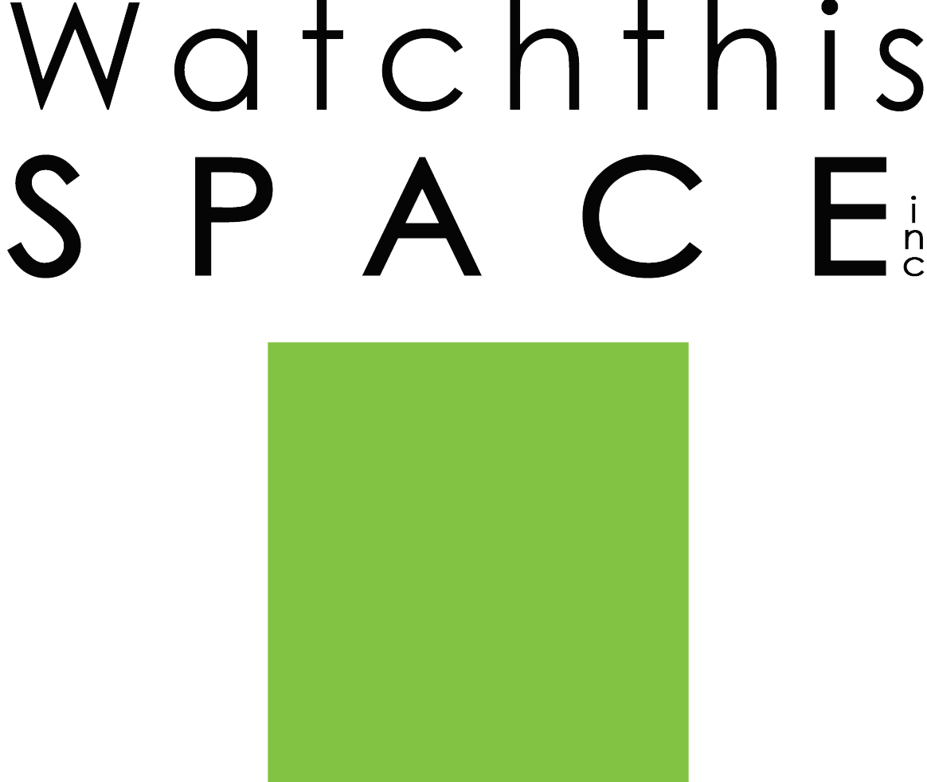
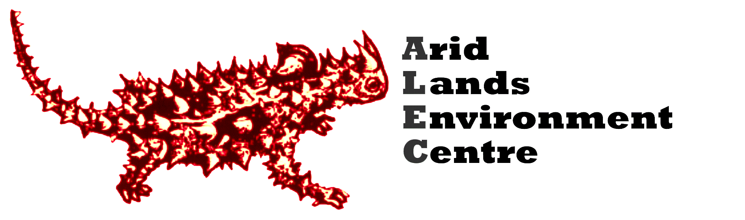

Better Together
World Environment Day Exhibition
Exhibition: 5th - 9th June 2018
Artist Application Form

“Alone we can do little, together we can do so much” Helen Keller
The Arid Lands Environment Centre (ALEC) and Watch This Space (WTS) are joining forces for the second year to present a collaborative exhibition for World Environment Day 2018.
You are invited to create an artwork that explores climate change solutions and the power of collective action.
We know that doom and gloom stories don’t motivate people to act. Artists are invited to contribute works that reflect the wonder of our environment, the strength of our communities and the work of millions of people across the planet actively working to create change.
Climate change is happening now and we are at a critical point in time where we need all hands on deck to bring about systemic change for a sustainable future.
We are seeking art pieces that inspire hope and remind people of the power in taking action. Think suns, solar energy, energy efficiency, tree planting, biodiversity conservation, community, gardening, cycling, taking a stand, speaking up, volunteering, donating, connecting to nature, love, courage, resilience, working together – we want to be inspired and for our community to be inspired!
We are asking artists of all mediums to contribute to this collaborative exhibition; painters, photographers, sculptors, woodworkers, textile artists etc.

In the spirit of reducing our ecological footprint all artworks, visual or sculptural, are to be no bigger than an A2 sheet of paper and under the price of $500. Artists are asked to donate 50-100% of the selling price to ALEC & WTS.
ALEC and WTS are valued long-standing local community organisations. All proceeds from sales of artworks will be split to support the work of both organisations.
The Arid Lands Environment Centre (ALEC) is Central Australia’s community environment organisation. For more than 38 years, ALEC has been a strong and trusted voice for the conservation and responsible management of the land, water and natural resources of Central Australia.

Watch this SPACE is the only contemporary experimental art space in Central Australia. It supports local, national and international artists, both emerging and established and has been supporting artists for more than 25 years.

ALEC and WTS are membership based organisations and are in constant need of fundraising to continue our work. Please support ALEC and WTS by contributing to this exhibition. The deadline for applications to the exhibition is Monday 14th May 2018.

Better Together Exhibition Application Form
Artist Details
Name…………………………………………………
Address…………………………………………………
Phone…………………………………………………….
Email……………………………………………………
Title of work (1) ……………………………………………………………
Medium…………………………………………………
Size………………………………………………………
Selling price………..
Would you like to donate 50% or 100% of sale price?
Title of work (2) ……………………………………………………………
Medium…………………………………………………
Size……………………………………………………
Selling price………..
Would you like to donate 50% or 100% of sale price?

Volunteers to sit the gallery, hang works and pack down
We are looking for interested people to help us hang/pack down the exhibition, sell works on the opening night and sit the gallery.
Can you help? Please circle YES / NO
If yes, please indicate what you can help with below:
Hanging works: Monday 4th June 12pm-4pm, Tuesday 10am-2pm
Selling artwork on opening night Tuesday 5th June 6-8pm
Sit the exhibition Saturday 9th June 10am-1pm or 1pm-4pm
Pack down Tuesday 12th June 10am-2pm
Conditions & Requirements
- All artworks are to be inspired by our environment and the issue of climate change.
- Each artist may submit no more than two pieces.
- All artwork is to be for sale and the price of $500 or under.
- Sculptural pieces must be moveable and have own pedestal/presentation if needed.
- Due to Watch This Space Gallery dimensions, size limits apply. Artworks are to be no bigger than A2 (42 x 59cm)
- There is no entry fee to the exhibition.
- No wet pieces will be accepted.
- While all care will be taken, no responsibility will be assumed for damage or loss to artworks. ALEC/WTS will take all due care with the artwork.
- Artworks will not be insured, if artists require insurance they must organise their own.
- Final decisions on the work to be displayed in ‘Better Together’ lies with WTS and ALEC, and we reserve the right to refuse pieces on the basis of inappropriate content, size, number of entries etc.
- Your application form must be received by Monday 14th May 2018
- Artists must include an Artwork Exhibition Form with each artwork that has all details of the piece, including the narrative if there is one.
- All entries are to be delivered Friday 25th May 10am-4pm at Watch This Space Gallery (artists are to organise alternative arrangements with WTS if not possible at that time)
- All unsold artworks must be picked up on Wednesday 13th June between 10am and 4pm from the Watch This Space Gallery (artists are to organise alternative arrangements with WTS if not possible at that time)

Please sign that you agree with the conditions;
……………………………………………………………………………………………
Please return this form to:

Scan and email: wts@wts.org.au
Postal: PO Box 8405 Alice Springs 0871 NT
In person: Watch This Space Gallery, 8 Gap Road Alice Springs

